Toad Edge Licensing FAQ

Contents

Q: Do you need an internet connection to use Toad Edge? 2

Q: My customer/prospect does not have consistent internet connection available for their users, can they use Toad Edge? 2

Q: My customer/prospect installed Toad Edge in the standard way and then discovered that they need a special OFFLINE license. Do they need to download and reinstall something new? 3

Q: My Customer purchased the standard version of Toad Edge but can’t use because their users don’t have internet connection! 4

Q: My Customer downloaded a trial for Toad Edge – does it support MySQL, Postgres or both? 4

Q: My Customer wants to purchase Toad Edge for MySQL and Toad Edge for Postgres – can they do this with one product? 4

Q: What are the Toad Edge for MySQL and Toad Edge for Postgres SKUs? 5

# Q: Do you need an internet connection to use Toad Edge?

A: For the Toad Edge product line we validate product licensing through an internet service. This allows Quest and our customers to view and manage their licensing online through our toad licensing web portal (<https://subscriptions.toadworld.com/>). This licensing validation will require that Toad Edge users supply a Toad World or Quest.com login at least once and, from that point forward, all licensing validation is done silently behind the scenes. However, this also means that Toad Edge users will need to have internet connectivity at least once in any given 30 day period so the license can continue to be validated. If a customer does not have consistent internet access, they can purchase the OFFLINE version of Toad Edge that does not require internet connectivity. When customers purchase the OFFLINE version of Toad Edge, they will be sent a signed license file as part of their purchase and they will need to follow the instructions in the ‘offline licensing’ area of the installation guide to install that licensing file so the product can function without internet access.

# Q: My customer/prospect does not have consistent internet connection available for their users, can they use Toad Edge?

A: Yes. Toad Edge comes with “OFFLINE” editions for both the trial and the commercial licenses. The product is exactly the same but you will need to provide special “OFFLINE” licensing for those customers who want/need to use the product without internet access.

For OFFLINE Trials:

The standard version of Toad Edge validates the trial license through a web service but the offline version will attach a signed license file to the license notification sent to the customer.   So, for them to start an offline trial, you will need to send them an ‘OFFLINE’ license from trial depot and they will need to follow the instructions in the ‘offline licensing’ area of the installation guide.

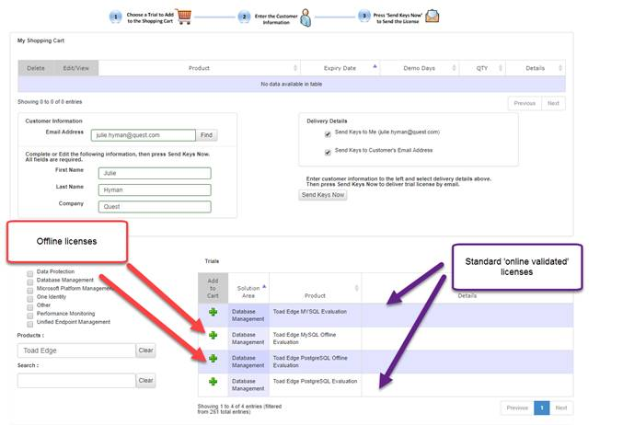

For OFFLINE Commercial:

To get the correct license to use the Toad Edge OFFLINE, the customer will need to purchase the correct Toad Edge SKU. The OFFLINE versions of the product have their own part numbers listed below. When the customer purchase these part numbers, a special license file is provided to them and they will need to follow the ‘offline licensing’ area of the installation guide to enact that license.

* OFF-TOD-TB TOAD EDGE MYSQL OFFLINE PER NAMED USER TERM LICENSE/MAINT
* PGO-TOD-TB TOAD EDGE FOR POSTGRESQL OFFLINE PER NAMED USER TERM LICENSE/MAINT

# Q: My customer/prospect installed Toad Edge in the standard way and then discovered that they need a special OFFLINE license. Do they need to download and reinstall something new?

A: No, both the standard online license validation and OFFLINE license validation version of Toad Edge are the same product. There is just a simple configuration change that needs to happen to switch from online validation to OFFLINE validation and vice versa. Once a customer has an OFFLINE license file (which they get sent to them either from a trial generated from the OFFLINE product in trial depot or from purchasing the correct OFFLINE SKU) they just need to follow the instructions in the installation guide about how to implement that offline license file in their already installed Toad Edge.

# Q: My Customer purchased the standard version of Toad Edge but can’t use because their users don’t have internet connection!

A: Toad Edge uses the internet to validate user licenses. For customers that don’t provide internet connectivity to their users, we offer a different kind of license. These OFFLINE customers need to purchase a special OFFLINE SKU (listed below) and are provided with a signed license file at time of purchase of one of these special offline SKUs. This signed license file is used by the product to validate the users’ licenses when there is no internet connectivity available. To indicate to the Toad Edge product that it should run in OFFLINE mode the user needs to create a license.cfg file in the …\Quest Software\Toad Edge\configuration folder that contains the path+filename for the license file. Customers can implement this configuration change manually or through a special install flag during install – all of this is outlined in the *Toad Edge Installation Guide* under the “Offline licensing” section.

* OFF-TOD-TB TOAD EDGE MYSQL OFFLINE PER NAMED USER TERM LICENSE/MAINT
* PGO-TOD-TB TOAD EDGE FOR POSTGRESQL OFFLINE PER NAMED USER TERM LICENSE/MAINT

If the customer needs to change from a standard Toad Edge purchase to a purchase of one of the special OFFLINE SKUs you will need to reach out to License and Upgrade Requests [license@quest.com](mailto:license@quest.com) to initiate the credit/rebill (for term licenses) or swap (for perpetual licenses). While this request is being processed you can visit trial depot (<https://trialdepot.webapps.quest.com/trialdepot/>) and generate a temporary OFFLINE trial for the customer to use. When they get their official license file after the credit/rebill or swap then can switch to the new license. They will not be required to reinstall Toad Edge for this.

# Q: My Customer downloaded a trial for Toad Edge – does it support MySQL, Postgres or both?

A: Toad Edge can support either MySQL, Postgres or both MySQL and Postgres depending on the licensing. When the customer downloads a trial version from Quest.com or Toad World, the online license activation will automatically grant them a 30-day trial of both Toad Edge for MySQL and Toad Edge for Postgres. You can also generate individual trials for either Toad Edge for MySQL or Toad Edge for Postgres from trial depot.

# Q: My Customer wants to purchase Toad Edge for MySQL and Toad Edge for Postgres – can they do this with one product?

A: Yes, Toad Edge can support either MySQL or Postgres or both depending on licensing. If your customer wants functionality for both MySQL and Postgres then you sell them a license for each of those products. They can layer in the licenses to Toad Edge to get a single product that supports both platforms.

# Q: What are the Toad Edge for MySQL and Toad Edge for Postgres SKUs?

A: The following are the SKUs for the standard version of Toad Edge:

MQT-TOD-TB      TOAD EDGE FOR MYSQL PER NAMED USER TERM LICENSE/MAINT

PGS-TOD-TB      TOAD EDGE FOR POSTGRESQL PER NAMED USER TERM LICENSE/MAINT

The following are the SKUs for the Offline version of Toad Edge:

OFF-TOD-TB TOAD EDGE MYSQL OFFLINE PER NAMED USER TERM LICENSE/MAINT

PGO-TOD-TB TOAD EDGE FOR POSTGRESQL OFFLINE PER NAMED USER TERM LICENSE/MAINT