Spotlight Integration with ServiceNow

The Spotlight integration with ServiceNow implementation is currently under consideration and is scheduled for the future release. We suggest to apply the below workaround to use emails to direct Spotlight alerts to ServiceNow.

Direct Spotlight Alerts to ServiceNow with Usage of Email
1. Configure ServiceNow instance email account to send and receive emails.
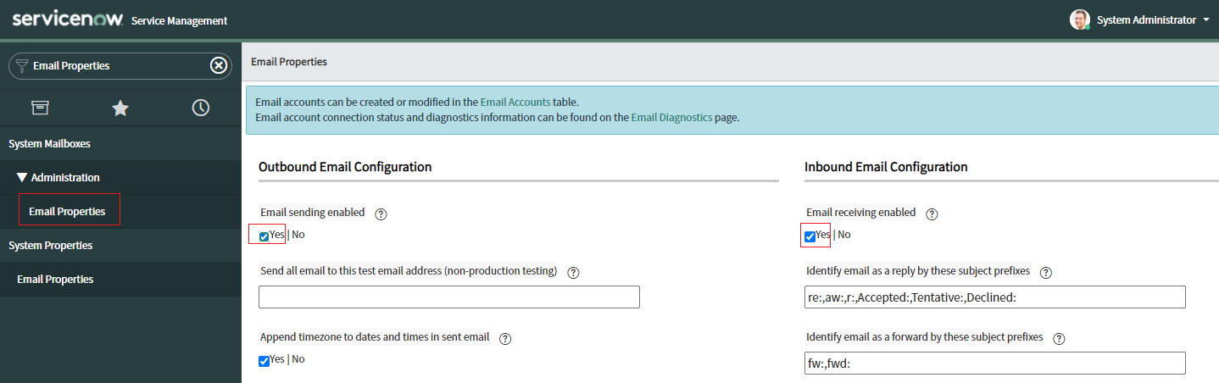

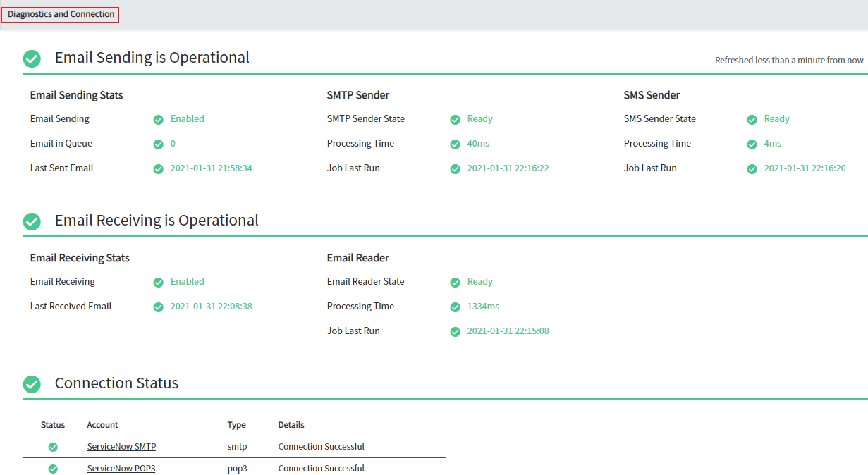

2. Go to Inbound Actions console and select existing Create Incident action (or create a new inbound action).

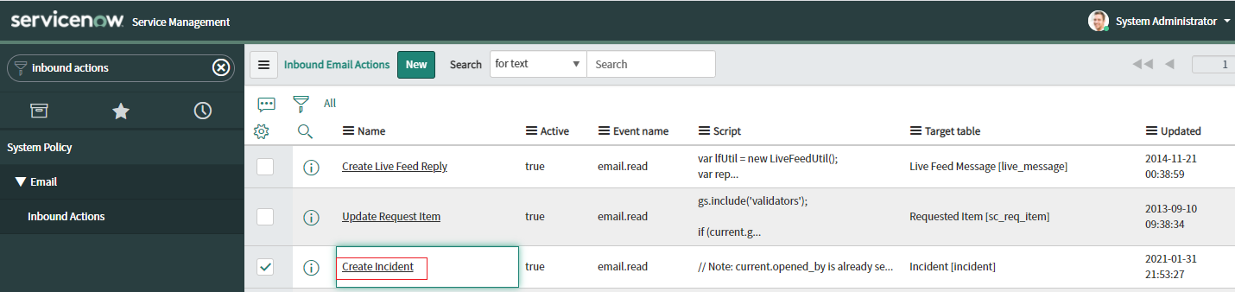

3. Define the highlighted conditions as desired. Set “Action type” to Record Actions setting. By default, we allow all emails sent to ServiceNow to create an incident. Below, demonstrates the simplest example. Define more actions under the Actions tab as needed.

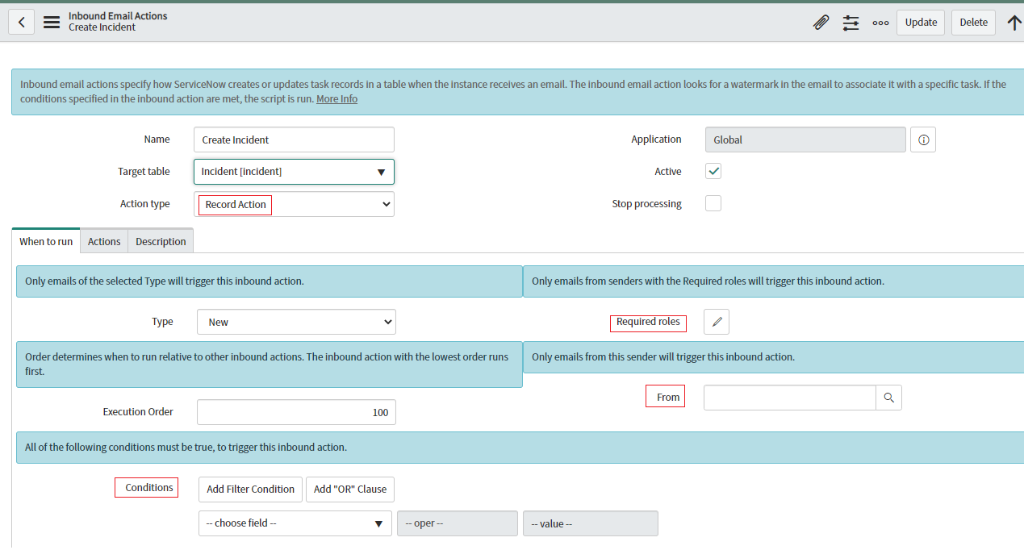

4. Configure Spotlight Alarm Action rules to send emails based on raised alerts to ServiceNow instance email account.

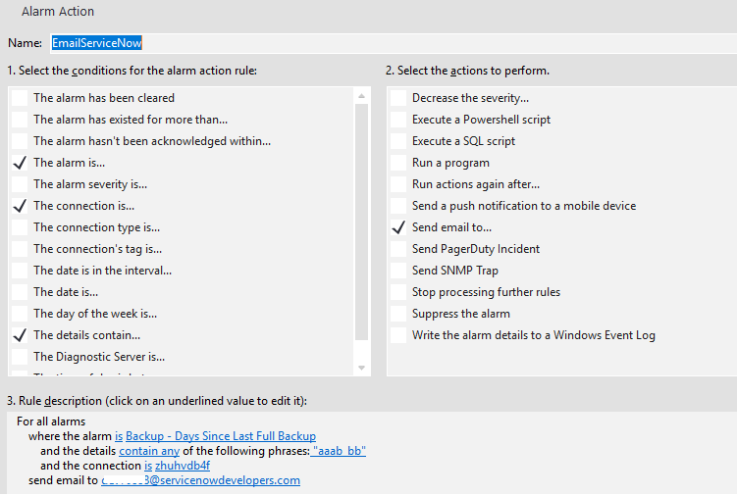

5. Trigger the alert in Spotlight.
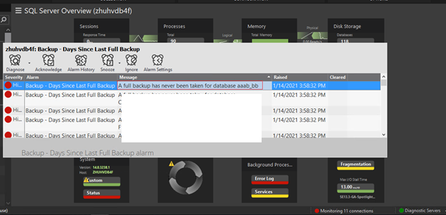

6. From the Service Desk | Incidents panel, we can see the created incident.
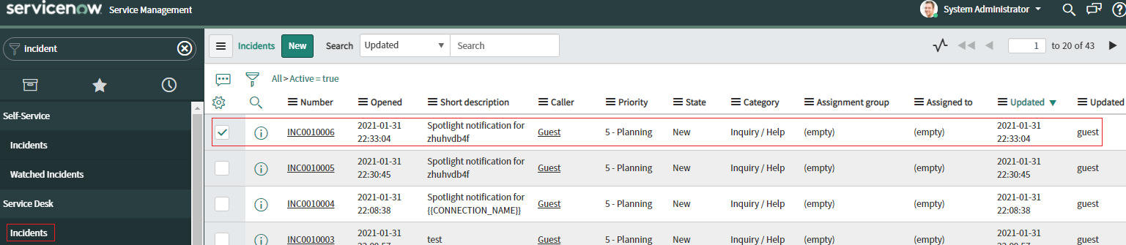

7. References

- https://docs.servicenow.com/bundle/quebec-servicenow-platform/page/administer/notification/concept/c_InboundEmailActions.html
- https://docs.servicenow.com/bundle/paris-servicenow-platform/page/administer/reference-pages/concept/c_EmailProperties.html

